**Applications of Machine Learning to Predict Reviews of New business**

Shiqing Chen, Jahnavi Nadipi, Wenliang Sun, Jiaru Zhu





**Table of Content**

1. Introduction
2. Background and Related Work
3. Problem Formulation
4. Datasets and Analysis
5. Proposed Ideas and Solutions
6. Experiments and Demonstration
7. Performance Evaluation
8. Conclusion
9. Reference
10. Appendix
11. **Introduction**

In this project, we brainstormed on Yelp which is a database of reviews, star ratings, and general information about businesses all over the United States. The information in the Yelp database are provided by the community, and the majority of the business are verified by the owners of the businesses. The main purpose of Yelp as a service is to provide consumers with a complete list of business based on consumers’ locations. Yelp also highlights its filtering functionality so that an especially specific service or business category can be limited to in the search results, for example Italian cuisine or foot spa. Yelp is a service that can help consumers decide on which businesses they would like to go, and such decision is primarily based on the consumer's preferences, and more importantly, on the reviews of such business.

There are many related research works on the Yelp database, which mainly focus on recommendation system. For consumers, the data from Yelp can be too much for them to swallow at a short amount of time, so it is often still difficult by just looking at the raw data. [1] Reading all the reviews of a single business alone is time consuming and requires more effort than the average consumer is willing to expend. As a result, a recommendation system is a helpful tool to predict how likely the consumer will like the business based on the data in the Yelp database. That’s to say, a recommendation system predicts the potential review stars of the business.

However, we make a step forward on the recommendation system. We believe that the idea of the recommendation system can be used to predict other meaningful things with some fundamental changes. Instead of recommending an existing business to a user by predicting the success/popularity of the business, we predict the success/popularity of a future business. In other words, we predict if a business with some prescribed features in a specific location will be successful, and the result is a score on a scale of zero to a hundred indicating how successful a business is with score zero as the least successful. Such score is then based on review stars and review counts. The review star is on a scale of one to five stars with a minimal of one star and a maximum of five stars. One-star stands for worst rating and five-stars stands for best rating. The popularity is based on review counts, a business with a review count of 100 has a better popularity than a business with a review count of 10, no matter how many stars they have.

Traditionally, there are two sets of features that are widely considered in the machine learning process of Yelp recommendation system. One is the set of features of businesses, and another is the set of features of preferences and previous reviews of the targeted user. In contrast, the recommendation system we propose uses features of locations and businesses.

At this stage of the project, we have focused on restaurants as business type, and we limit the locations of the businesses in the following college towns: State College, Ithaca, Columbus, and Champaign.

1. **Background and Related Works**

Previously work on Yelp has mainly focus on the popularity of each restaurant, while less effort has been devoted to recommend a type of restaurant to open for people who want to have a popular restaurant. Such as Bochkov and Gingerich have already conducted similar analysis on restaurants based on text analysis and word vectors, in another paper, Yun, Wu, and Wang explored using Part-of-Speech analysis to predict a restaurant’ rating based on user-generated text alone. However, the existing works in the literature do not consider the comprehensive factors how to affect the popularity of restaurants. In addition, none of the works in the literature considers the problem of regional differences.

This report has mentioned an recommendation model that would greatly reduce the decision cost for choose a proper type of restaurant to open in different cities. In the first part, we have a preprocess to clean the Yelp data. Secondly, we compare different data mining models, such as SVM, decision tree, random forest, by using some evaluation metrics. This operation aims to choose a best model to input our dataset. In addition, we also analyze the data to find the basic relationships among some attributes and use some visualization approaches to get them. According on the analysis result, we make a black-box model. We just put the city, cuisine type and some other basic information into the model and then we will get the recommendations about that how to open a popular restaurant.

1. **Problem formulation**

Can we get a model that could predict a restaurant will be popular in some city? We want to get the model from the big Yelp dataset and the model should be robust, usable and powerful.

1. **Datasets and Analysis**

The dataset was obtained from Yelp Dataset Challenge website. The dataset itself contains almost 5 million reviews from over 1.1 million users on over 150,000 businesses from 12 metropolitan areas. A preview of the JSON file



This set contains 5 different .JSON files including:

1. Business.JSON: This file consists of 156,639 rows of nominal data with various attributes such as the business ID associated with a particular business, name of the business, address, category it belongs to, working hours, price range etc.
2. The binary attributes in this set mentions the presence or absence of a particular attribute such as parking, wheelchair accessibility etc. The business.JSON list is as follows:

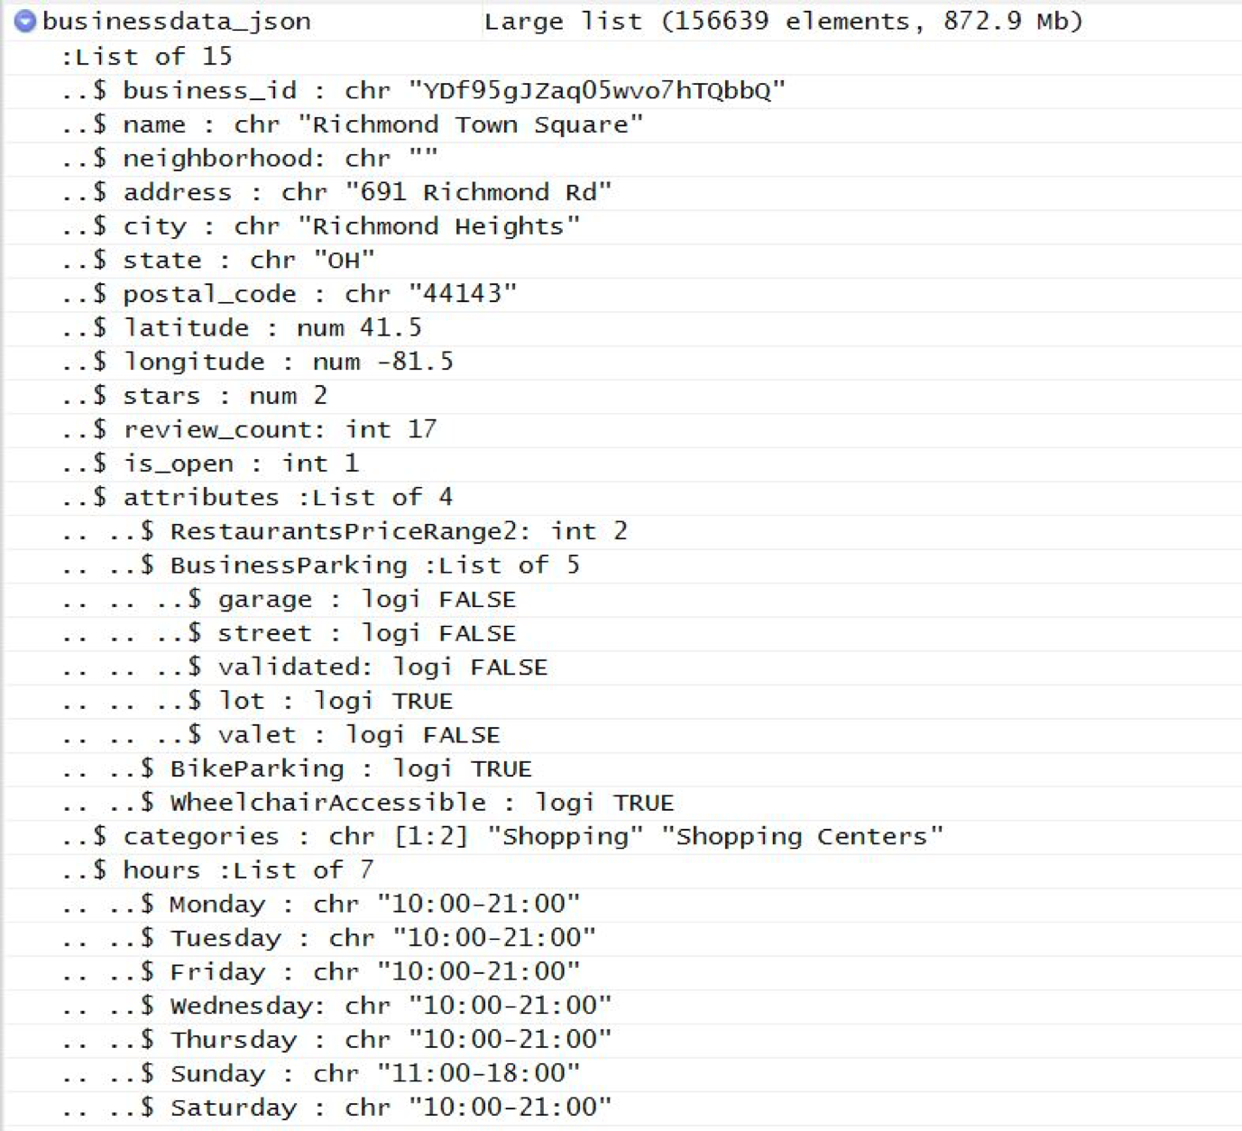

3. Checkin.JSON: This JSON file is made of 135418 elements in the list with the check-in details on various days during various timings for every business in a week.

4. Review.JSON: This file has 4736897 elements in the list consisting of data about the review ID, user ID, business ID, stars by user, date and the review.

5. Tip.JSON: It contains 1028802 elements including business ID, user ID, likes, text and review.

6. User.JSON: User.JSON contains 1183362 elements with user information such as user ID, user name, review count, average stars, no. of compliments provided and others.

Review Counts

In the 5,207 Pittsburgh restaurant records that we have extracted from Yelp, the review count ranges from 3 to 1,353. The mean of review count is 30, and the medium is 10.

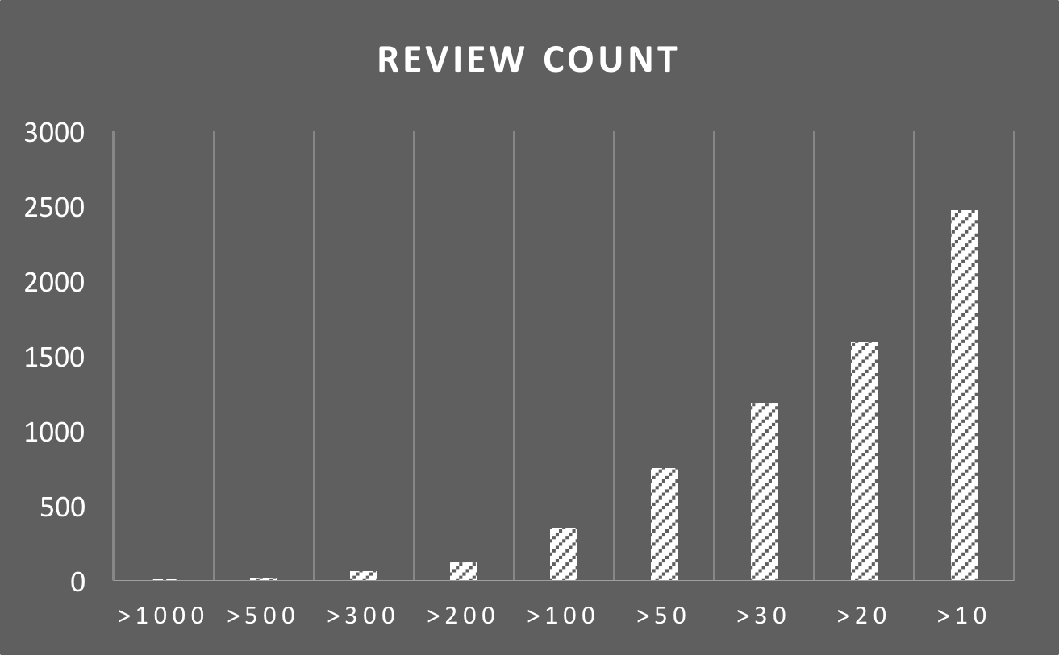

Above is the table for the distribution of review count. As you can see, just about half of the businesses have fewer than ten review counts. Only 3 of 5,207 business have review count over 1000, and 10 business have review count from 500 to 1000. We have made a review count scatter plot based on location:

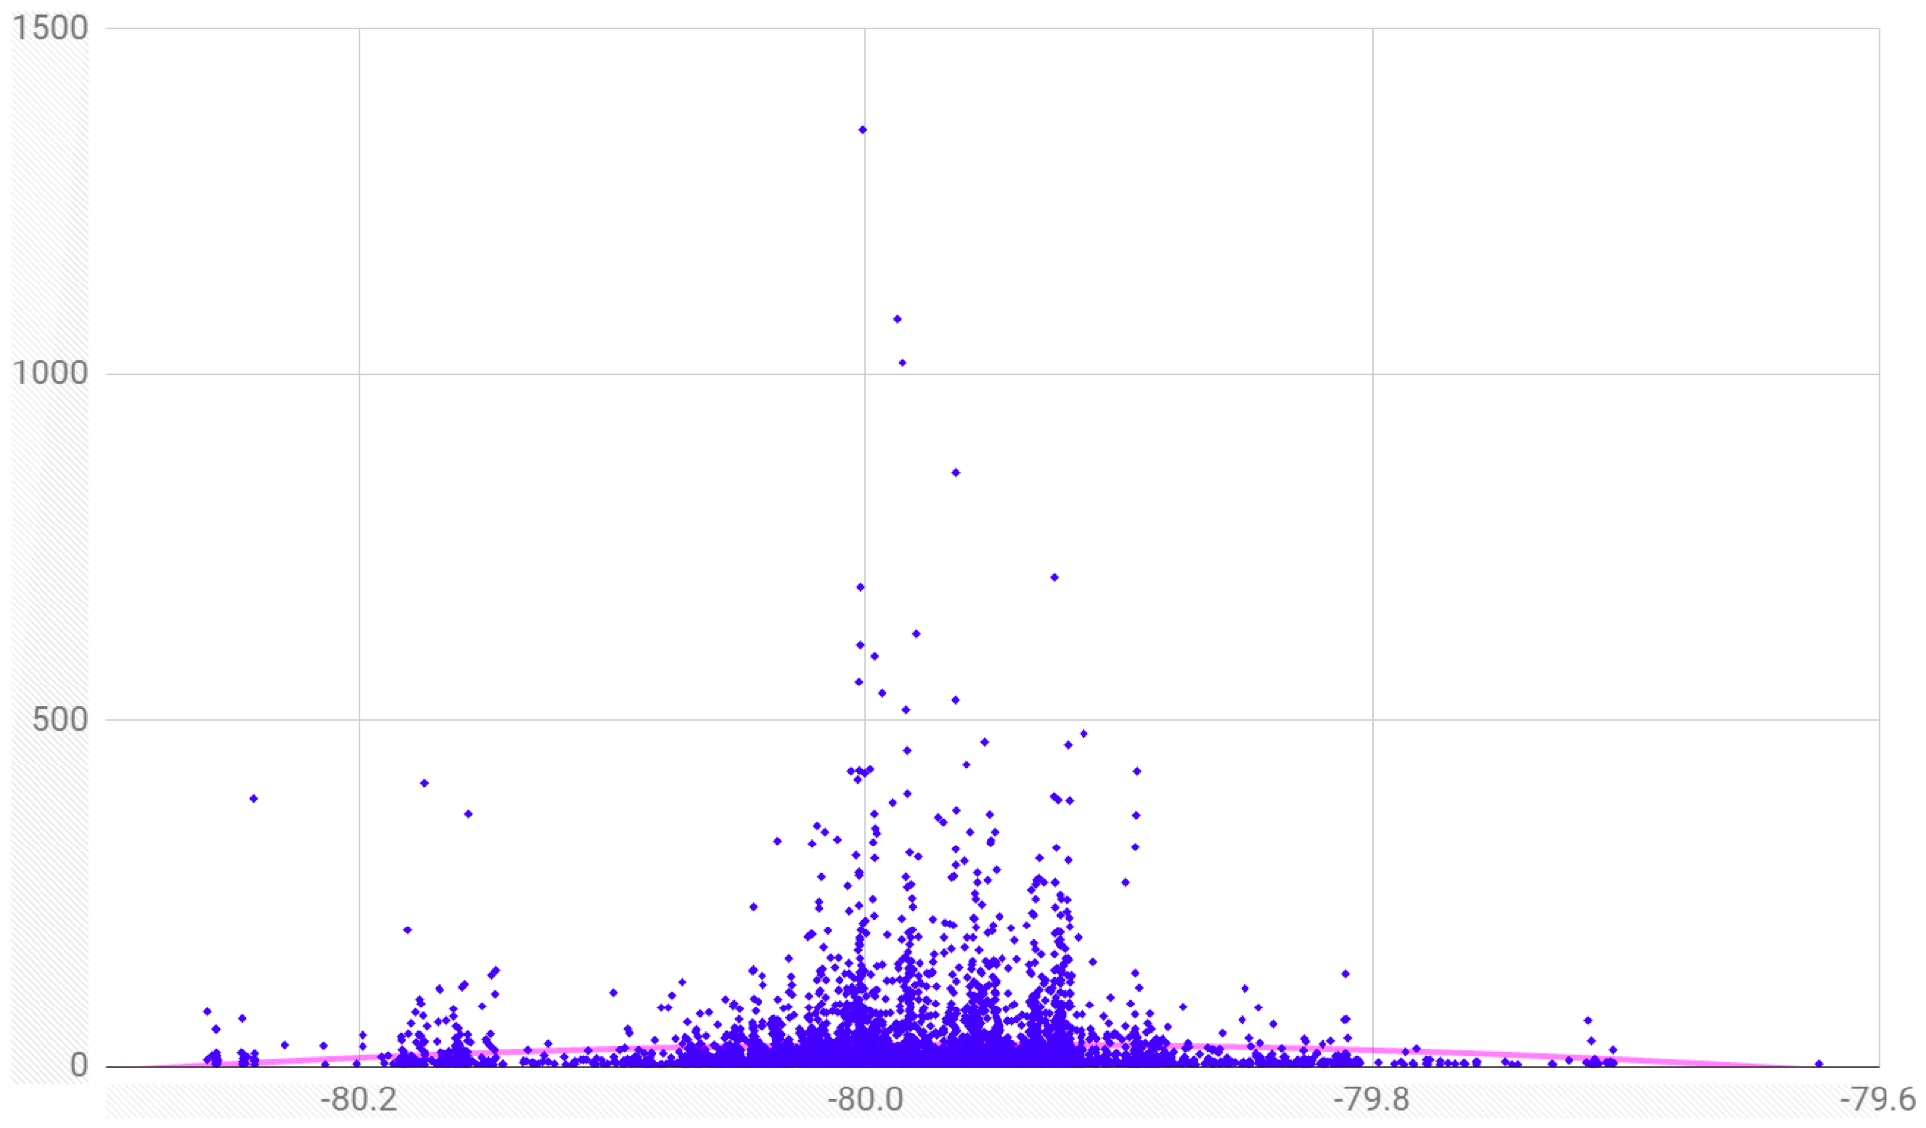

From the above figure, we can conclude that the most popular business with higher review counts are scattered in the central Pittsburgh which is the Downtown area.

Review Stars

In the 5,207 Pittsburgh restaurant records that we have extracted from Yelp, the review count ranges from 1 to 5. The mean of review count is 3.64, and the medium is 3.5.

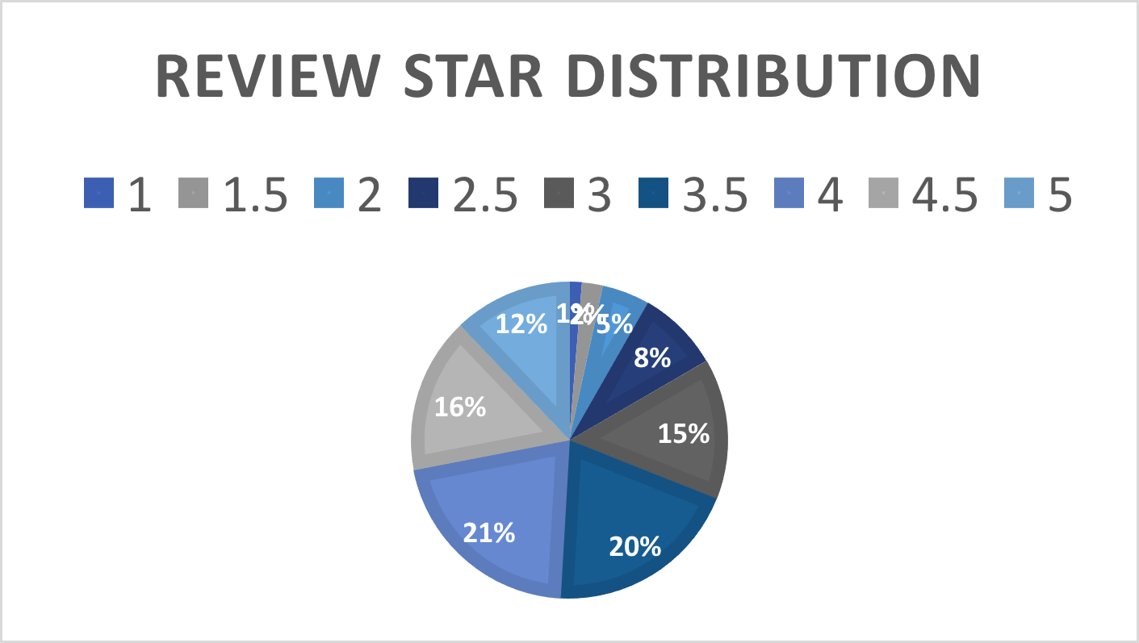

Above is the distribution of review stars, and as you can see, just about half of the 5,207 restaurants have scored higher than or equal to four stars. The chart below shows the relationship between the review star average and the review count of a restaurant. As you can see, there is actually a trend in the review stars that the more review counts it gets the more review stars it has. It means that the popularity and the quality of a restaurant is mostly co-related. The more popularity a restaurant is the more review stars you can expect.

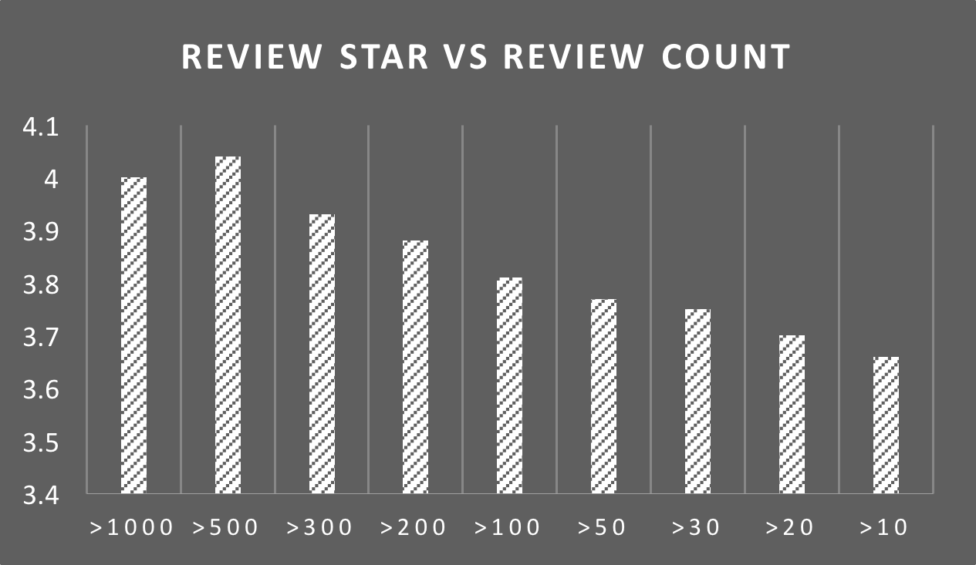

1. **Proposed ideas and solutions**

Since we have converted the data into numerical, we have divided these data into two different modes. The first one is binary. For example, we have two kinds of noise level, which are average or very loud. Labeling average as 0, and very loud as 1. Naive Bayes, decision tree, and support vector machine are three machine learning models that we were using to train and test data through binary modes. Additionally, the other mode is called multi-class. To illustration, we have obtained star rating from 0 to 5, which are stored as integers from 0 to 5. These models are implemented in Support Vector Machine, decision tree, rule-based classifier.

5.1 Naive Bayes

Our project uses the Multinomial Naive Bayes classifier with a Laplace smoothing value of α = 1.0. Using all of the countries data, the test accuracy was 0.5517. The results for each separate city are included in the results section of our paper. The test accuracy ranges from 0.4725 for the State College to 0.5846 for Pittsburgh. The equations used are included below:

5.2 Logistic regression

For logistic regression, the test accuracies varied depending on the regularization. We used logistic regression by Skicit, where the inverse of regularization strength is represented by parameter C. Improving or reducing C by factors of 10 does not yield significant differences in test accuracy, but we noticed that a higher C-value, results in higher test accuracy.

5.3 Decision tree

We used Decision Tree algorithm to generate the decision tree, with 15 cross-validation Folds. The attributes that we have are separated into two parts:

* Static Factors: Not directly linked with food. These factors are binary. E.g. Has parking, Has WiFi, Has TV. （See Model 1)
* Dynamic factors: directly linked with dining experience. Basically, these factors has more than two values. E.g. Food quality, Portion size. (See Model 2)

Depending on the decision trees, we set up three possible outcomes for static factor tree, which are excellent, good and average.

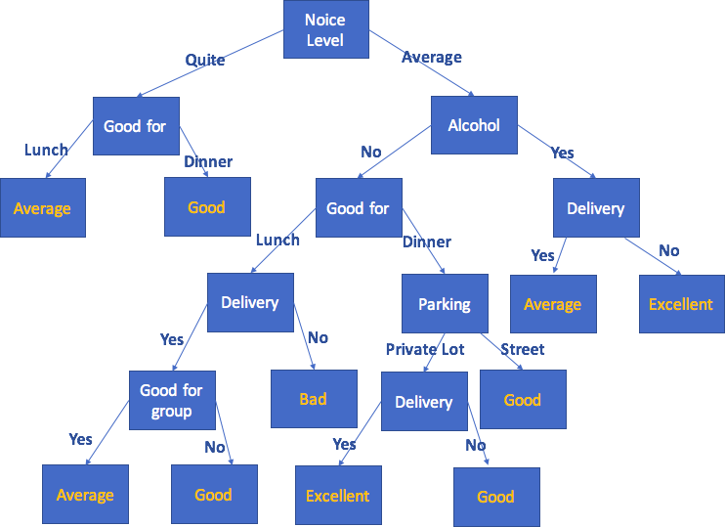

Model 1

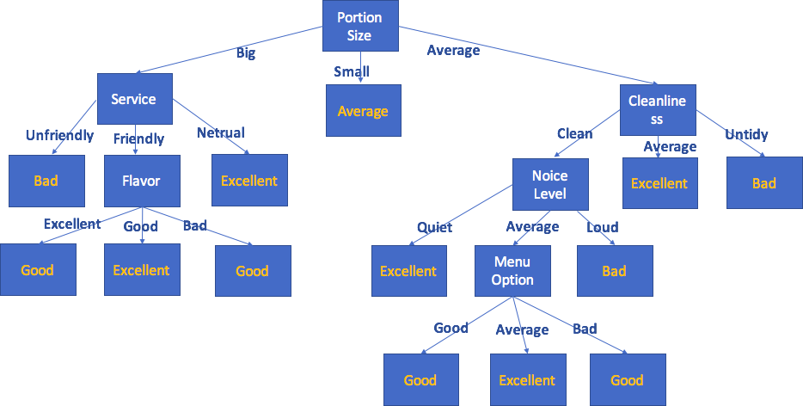

Model 2

From our decision tree model 1, we observed that people like to dine in restaurant that are Good for Dinner, have a Private parking lot and deliver the food and Noise level is Quiet or Average. The result is pretty similar as we expected. This indicates that most of customers in our dataset are willing to go to restaurant at Dinner time, so that the restaurant should pay fully attention on PM hours. Also, lunch buffet traffic is comparatively less than Diner traffic, so that reducing the price of lunch buffet is a good choice. What’s more, the delivery service is another important features that ought to be considered, since there are quite amount of customers that are requiring delivery.

From our decision tree model 2, we knew that a BIG portion size with Friendly or Neutral customer service can influence the rating positively and very quickly. Since portion size is the main factor that may causing bankrupt for a restaurant, a restaurant may still receive average rating if its portion size is small, even if the restaurant offers excellent service, WiFI, and cheap price. In addition, people who live in residential area highly hate the noise level with loud. This may immediately lead to a poor rating. What’s more, menu is not a major factor that affecting the success of a restaurant. Focusing on offering variety of food items or being creative with offerings, the restaurant should focus more on portion size, cleanliness and noise level, to make the success.

From statistics of static factor tree, the overall result is not that convincing, since the confidence level is 56.67%. Nonetheless, the ROC area of “Good” is 0.912, and 0.814 for “Average”, which means the accuracy of this model for “Good” and “Average” ratings is highly more than “Excellent” and “Poor” ratings.

From statistics of dynamic factor tree, the overall result is fully proof and extremely convincing, since the confidence level is 100%. The factors that are said to cause failure will certainly lead to failure, so that avoiding these factors are necessary in the processing of success.

As we can infer from above, the following table is the specific factors that drive a customer’s experience. The table below indicates the key factors that influencing the success of opening a restaurant. We selected 18 attributes, and giving a rank for them based on the score they obtained. (See table below)

|  |  |  |
| --- | --- | --- |
| **Attribute** | **Influence Rank** | **Score** |
| **Portion size** | **1** | **100** |
| **Delivery** | **2** | **94** |
| **Good for group** | **3** | **89** |
| **Noise** | **4** | **83** |
| **service** | **5** | **78** |
| **Cleanliness** | **6** | **72** |
| **Wi-fi** | **7** | **67** |
| **Price** | **8** | **61** |
| **TV** | **9** | **56** |
| **Parking** | **10** | **50** |
| **Quality** | **11** | **44** |
| **Ambience** | **12** | **39** |
| **Reservation** | **13** | **33** |
| **Outdoor seating** | **14** | **28** |
| **Menu** | **15** | **22** |
| **Location** | **16** | **17** |
| **Flavor** | **17** | **11** |
| **Accept credit card** | **18** | **6** |

5.4 Support Vector Machines (SVM)

For support vector machine, we have tried three different kinds of SVM by using Scikit SVM, and we obtain the following table:

|  |  |  |  |
| --- | --- | --- | --- |
|  | Linear | Gaussian | Polynomial (d =2) |
| Training Accuracy | 0.4515 | 0.4508 | 0.4279 |
| Test Accuracy | 0.4413 | 0.4323 | 0.4136 |

Obviously, we can find out that linear is little more accurate than other two, so that we will use linear kernel when we move forward.

Finally, we have tried logistic regression by Skicit. Our binary test accuracy as shown in the table below, but for the multi-class, we will continue study in the future. Even though the results are quiet similar, but still we can say increasing c with 100 is the best choice.

|  |  |
| --- | --- |
| C | Binary Test Accuracy |
| 0.01 | 0.5398 |
| 0.1 | 0.5485 |
| 1.0 | 0.5503 |
| 10.0 | 0.5505 |
| 100.0 | 0.5506 |

What’s more, decision tree is much more accurate than SVM and logistic regression, but it requires lot of time to implement all of data. We don’t know how other machine learning models will perform yet, but we will work on it in the following several weeks.

5.5 KNN algorithm

In our project, every location point is such as (x, y). To classify the restaurants in different locations, we choose KNN algorithm. Basically, some restaurants are popular because of the location. We use the following pseudocode to express our ideas:

Method: KNN (A [n], k)

*# Enter: A [n] is the coordinate of N training samples in space, k is the number of neighbors*

*# Output: x belongs to the category*

*(X, A [i]), i = 1, 2, ..., k is taken as the initial distance between x [1] and A [k] as x,*

*Sort by d (x, A [i]) in ascending order;*

*The maximum distance of the sample is D = max {d (x, a [j]) | j = 1,2, ..., k};*

*# Continue to calculate the Euclidean distance of the remaining n-k data*

*for (i = k + 1; i <= n; i ++)*

*Calculate the distance d (x, A [i]) between a [i] and x;*

*if (d (x, A [i])) <D*

*use A [i] instead of the farthest sample*

*# Will be followed by the calculation of the data can be inserted directly*

The probability of the category of the first k samples A [i], i = 1,2, .., k is calculated by the order of the K data, and then the statistics of the K samples are calculated. The category is the class of sample x. By this algorithm, we can calculate the distances between any two points and draw a heat-map as below:

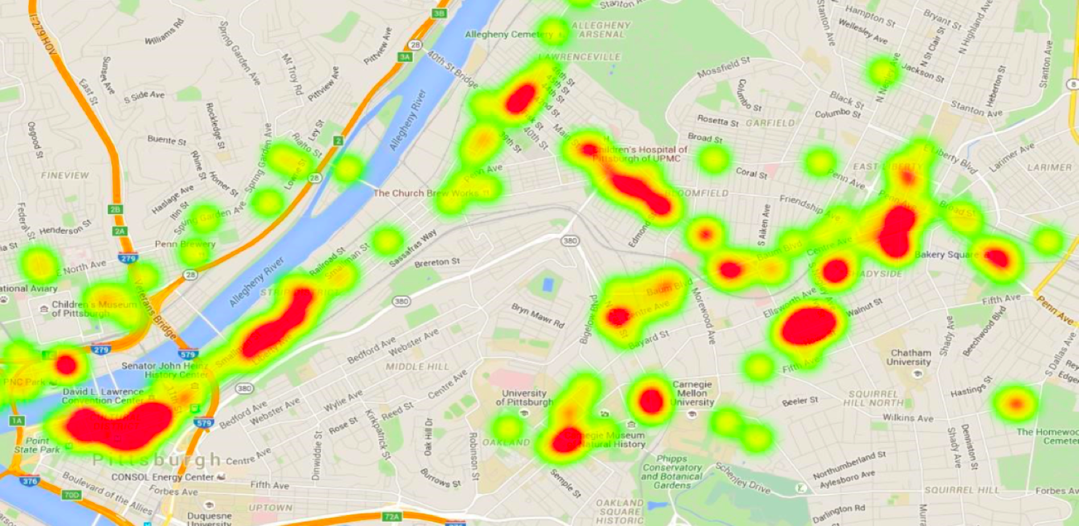

5.6 K-means

K-means is an unsupervised learning algorithm that groups the features into a set number of clusters. We use the k-means clustering algorithm using the recommendation power metric as similarity difference to partition the users into a set Ca of k1 user clusters and partition the restaurants into a set Cb of k2 restaurant clusters. We set the number of clusters to 2 for binary classification and multi-class classification. We observed the train accuracy is a little bit bigger than the test accuracy. In the k-means model, we select K points stand for the centroids. And then form K clusters by assigning all points to the closest centroid. After that, we compute the centroid of each cluster. We should repeat the two steps until our centroids don’t change. In our project we initial our centroid are often chosen randomly. And the centroid is the mean of the points in the cluster. Using the closeness to measure similarity. We also use the SSE to evaluate our k-means model. A good clustering with smaller k will have a lower SSE than a poor clustering with higher k. In addition, in the basic k-means algorithm, we update the centroids after all points are assigned to a centroid. And also we can use the pre-processing, such as normalize the data and eliminate outliers, to reduce the SSE. The post-processing approaches are also work well in our project. We use the k-means model on a 17-restaurant data.

5.7 Analysis of Text Reviews

Customer review text is another significant attribute that we are looking for in order to indicate the success of restaurants. In this section, we will show important features that extracting from text reviews. For example, words like “worst”, “problem”, “oil” are extracting from users who rating with just 1 star (see Figure 4.6.1). However, works like “ friendly”, “nice”, “good” are obviously positive reviews, which come from ratings of 5 stars (see Figure 4.6.2). These features are significant so that we perform some sentiment analysis on them, and we separate the analysis into several steps as below:

* **Preprocessing:** Grouping all related text reviews of the same restaurant into just one text review with space separators by business id (from dataset).
* **Feature Extraction:** Calculating the word frequencies from the words that extracting from text reviews which grouped by last step. Then, We convert a collection grouped text reviews to a matrix of features through SKLearn.
* **Finding Optimal Features:** The best set of features are these features with the highest chi-squared score, which calculating by using chi-squared test.
* **Prediction:** Try the approaches mentioned previously to predict the success of restaurant.

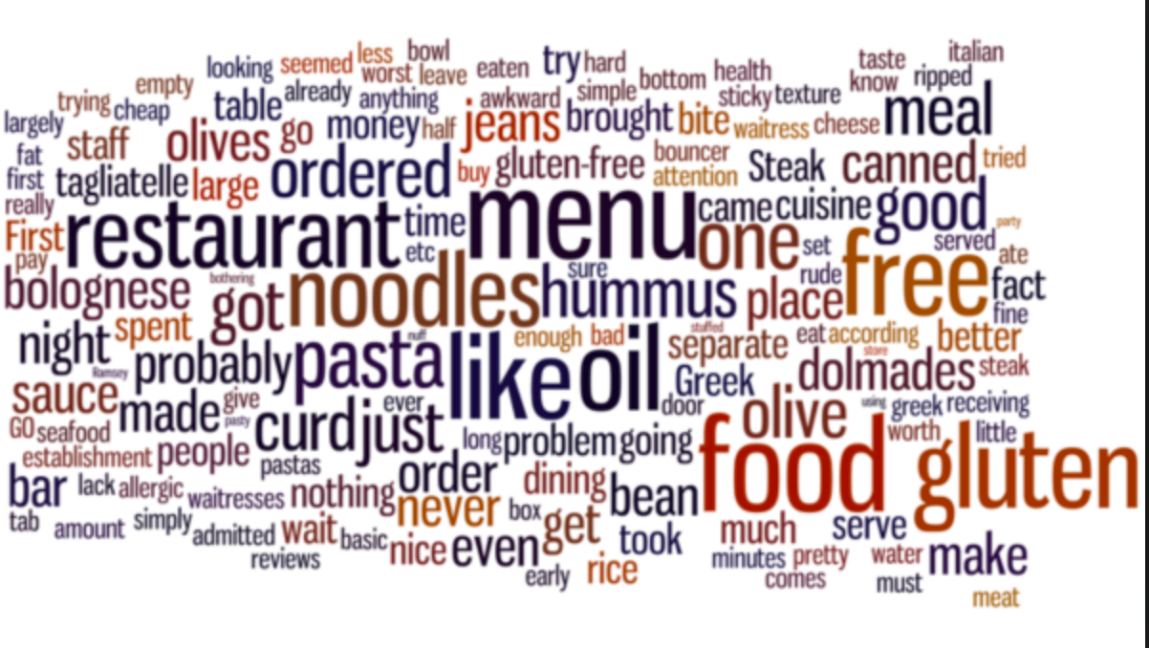

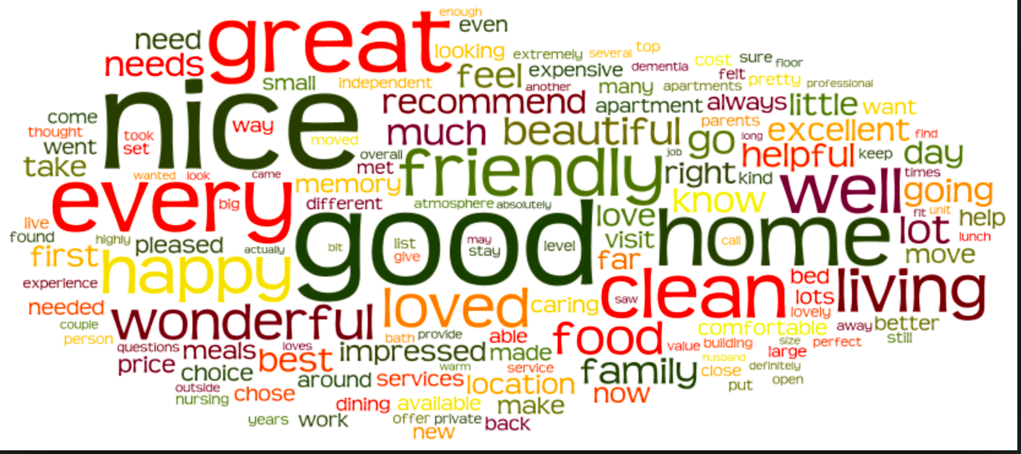

1. **Experiments and Demonstartion**

We use several development languages and tools in our project. The development languages include: Java, Python and MATLAB. We also use Git for better teamwork. In addition, we select some powerful libraries in different languages and we will not mention here.

Since we have converted the data into numerical, we have divided these data into two different modes. The first one is binary. For example, we have two kinds of noise level, which are average or very loud. Labeling average as 0, and very loud as 1. Naive Bayes, decision tree, and support vector machine are three machine learning models that we were using to train and test data through binary modes. Additionally, the other mode is called multi-class. To illustration, we have obtained star rating from 0 to 5, which are stored as integers from 0 to 5. These models are implemented in Support Vector Machine, decision tree, rule-based classifier.

For each machine learning models, we trained and tested data from restaurants around state college and other cities have similar circumstances. We have set up a test case with score 100, which show below:

Have Wifi: 0 (yes) (binary) score: 5

Have delivery: 0 (yes) (binary) score: 5

Have take-out: 0 (yes) (binary) score: 5

Accept credit cards: 0 (yes) (binary) score: 5

Noise level: 0 (average level) (binary) score: 4

Price range: 1 (number of $, maximum 5) (Multi-class) score: 10 (one more $ will count down 2 points)

Star rating: 0 (number of stars, maximum 5) (Multi-class) score: 36 (one more star will count down 6 points. Also, there might be half star, which represents 3 points)

Review counts: # of negative reviews / # of total reviews = 0 score: 30 (percentage * 30)

For each city, we chosen 75% of restaurants’ data to train on and the rest of data to test on.

1. **Performance Evaluation**

According the figure 7.1 and figure 7.2, when we run the binary and multiclass classifiers on the features, we discovered that SVC and decision tree performed the excellent. Since both these algorithms perform more optimally than other models that are sensitive to outliers in dataset. We could expect that a restaurant’s features will not be interact linearly. For example, a restaurant maybe have a very high rating with classy ambience and low noise level, but a restaurant with a casual ambience and high noise level can also be successful. These two algorithms also could control the over-fitting. In addition to running the classification algorithms on all restaurants, we also run the multi-class classifiers separately on restaurants from different cities within the US.

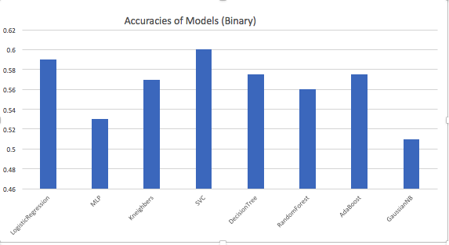

Figure 7.1

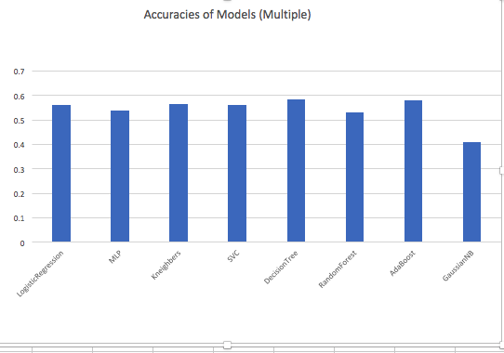

Figure 7.2

1. **Conclusion**

IX. **References**

[1] Zhang T, Pan Y. Yelp Challenge Project Report[J]. University of Washington Publication, 2014.

[2] Fan M, Khademi M. Predicting a business star in yelp from its reviews text alone[J]. arXiv preprint arXiv:1401.0864, 2014.

[3] Asghar N. Yelp Dataset Challenge: Review Rating Prediction[J]. arXiv preprint arXiv:1605.05362, 2016.

[4] Luca M. Reviews, reputation, and revenue: The case of Yelp. com[J]. 2016.

[5] JSON Functions and Operators http://www.pos tgresql.org/docs/devel/static/functions - json.html

[6] Momjian, Bruce. PostgreSQL: introduction and concepts. Vol. 192. Addison - Wesley, 2001.

[7] Ramakrishnan, Raghu , and Johannes Gehrke. Database management systems. 、Osborne/McGraw - Hill, 2000.

[8] Json usage. https:/ /code.google.com/p/json - simple/downloads/list

[9] Cardinal, Rudolf N., and Michael RF Aitken. ANOVA for the behavioural sciences researcher. Lawrence Erlbaum Associates Publishers, 2006 .

[10] Kutner, Michael H., Chris Nachtsheim, and John Neter. "Applied linear regression models." (2004) .

[11] Kester, Walter Allan, ed. Data conversion handbook . Newnes, 2005 . ”Yelp Dataset Challenge.” Yelp. N.p., n.d. Web. 01 June 2016.¡https://www.yelp.com/dataset challenge. ”An Introduction to Yelp Metrics as of March 31, 2016.” Yelp. N.p., n.d. Web. 26 May 2016.

[12] Gingerich, Travis, and Yevhen Bochkov. ”Predicting Business Ratings on Yelp.” Stanford University. 2015.

[13] Xu, Yun, Xinhui Wu, and Qinxia Wang. Sentiment Analysis of Yelps Ratings Based on Text Reviews.” Stanford University. 2015.

[14] ”Missing Problems in Machine Learning.” Marlin, M. Benjamin. Graduate Department of Computer Science University of Toronto. 2008.

[15] Xu, Qing-Song and Yi-Zeng Liang. ”Monte Carlo Cross Validation.” Chemometrics and Intelligent Laboratory. 6 July 2000.

[16] Burges, Chris. ”From Stumps to Trees to Forests.” Cortana Intelligence and ML Blog Team, 10 Sept. 2014. Web. 06 June 2016.

[17] ”1.10. Decision Trees.” 1.10. Decision Trees Scikit- learn 0.17.1 Documentation. N.p., n.d. Web. 06 June 2016.

[18] Ng, Andrew. ”CS 229: Generative Learning Algo- rithms.” Stanford University.

X.  **Appendix**

In this project, we used many approaches and methods that we have learn in our data meaning course. We use decision tree to find some specific factors that drive a customer's experience.We use the rule-based method to get the condition that the decision tree need. In addition, we use k-Means to group the features into a set of number clusters, such as the restaurant locations. The Naive Bayes was used to look at each feature independently. Because the Naive Bayes is robust to the isolated noise points and irrelevant attributes, it also could handle missing values by ignoring the instance during probability estimate calculations. Because of the SVM high performance to high-dimensional data, we use it to train our model. And the SVM characteristic is that represent the decision boundary by support vectors derived from a subset of training examples. We use the maximal margin hyperplane to linearly separate the data objects of different classes. And we also use the accuracy to evaluate different classifiers. However, we also encountered some issues during the project. The first one is that the big dataset. For a big dataset, there must be many noise and irrelative points and it is also tough to preprocess for any program. The Yelp dataset include about 6 GB data, so we should use high performance software and computer. And the second one is the visualization part. Because we should transform the data format and cut into several segments. And the city size is also a big challenge. There are many small towns, such as State College, so our model maybe not work very well in these places. And the competition among similar restaurants is also a crucial factor. The last one is the accuracy is not good enough but we will sort the restaurant into categories before running our model.